### A

**Project Report on**

“Online Blogging System”

SUBMITED BY:-

Mr.Sanket Devidas Khote

### Guide BY:-

**Prof. Borade A.B**

SUBMITED TO:

SAVITRIBAI PHULE PUNEUNIVERSITY

### IN PARTIAL FULLFILMENT OF

T.Y.B.Sc (Comp .sci.)

### SHRI CHHATRAPATI SHIVAJI MAHAVIDYALAYA SHRIGONDA, DIST-A-NAGAR, PIN 413701

ACADMIC YEAR-2022-2023



## SHRI CHHATRAPATI SHIVAJI MAHAVIDYALAYA

SHIVAJINAGAR, SHRIGONDA-413701, DIST-AHMEDNAGAR

Date: / /2023

**CERTIFICATE OF PROJECT COMPLETION**

**Certified that Project/Field work Report titled**

# “ONLINE BLOGGING SYSTEM”

Has been completed satisfactory in partial fulfillment of B.Sc. (Computer Science), Course of **“SAVITRIBAI PHULE PUNE**

**UNIVERSITY”** for the academic Year 2022-2023 by the following student of

#### “SHRI CHHATRAPATI SHIVAJI MAHAVIDYALAYA”, SHRIGONDA.

**Name of the Student:-**

Mr.Sanket Devidas Khote

**Place:** SHRIGONDA.

#### Seen By:-

**Principle**

S.C.S.M, SHRIGONDA

Internal Examiner Sign External Examiner Sign

**ACKNOWLEDGEMENT**

I would like to take this opportunity to express my gratitude

toward all the People who have in various ways, helped in the successful completion of my project.

I must convey my gratitude to **Prof.Borade A.B** for giving me

the constantsource of inspiration& help in preparing the project, personally correcting my work & providing encouragement throughout the project.

I also thank all my faculty members for steering me through the tough as well as easy phase of the project in a result oriented manner with concern attention.

**Table of Content**

|  |  |
| --- | --- |
| **Sr.No** | **Contents** |
| **Ch.1** | **Introduction/Abstract** |
| 1.1 | Motivation |
| 1.2 | Problem statement |
| 1.3 | Purpose/Objective and goals |
| 1.4 | Literature survey |
| 1.5 | Project scope and limitations |
| **Ch.2** | **System Analysis** |
| 2.1 | Existing system |
| 2.2 | Scope and limitations of existing systems |
| 2.3 | Project prespective, features |
| 2.4 | Stakeholders |
| 2.5 | Requirements analysis |
| **Ch.3** | **System Design** |
| 3.1 | ER Diagram |
| 3.2 | UML Diagram |
| **Ch.4** | **Implementation details** |
| **Ch.5** | **Output and Reports Testing** |
| **Ch.6** | **Conclusion** |
| **Ch.7** | **Future scope** |
| **Ch.8** | **Bibliography and References** |

**INTRODUCTION**

**1.1 System Introduction: -**

This project Online Blogging System has been developed on PHP and MySQL. The

main purpose for developing this project Online Blogging System is to managing

users only where people can share their ideas and discuss on any topics. It can help

for users who can publish daily journal entries. It gives everyone his or her own

personal views to publish to the world. This project provides a lot of features to

rristinge in very well manner. This application has a good appearance and is very

easy to operate. This project contains a lot of advance modules which makes the

back-end system very powerful.

"Blog" is an abbreviated version of "weblog," which is a term used to describe

websites that maintain an ongoing chronicle of information. A blog features diary-

type commentary and links to articles on other websites, usually presented as a list

of entries in reverse chronological order. Blogs range from the personal to the

political, and can focus on one narrow subject or a whole range of subjects.

Many blogs focus on a particular topic, such as web design, home staging, sports,

or mobile technology. Some are more eclectic, presenting links to all types of other

sites. And others are more like personal journals, presenting the author's daily life

and thoughts.

Generally speaking (although there are exceptions), blogs tend to have a few things

in common:

* A main content area with articles listed chronologically, newest on top. Often,

the articles are organized into categories.

* An archive of older articles.
* A way for people to leave comments about the articles.
* A list of links to other related sites, sometimes called a "blogroll"

# Existing System

# The purpose this system is to automate the existing manual system by the help of computerized equipment & full-filled by computer software. Fulfilling their requirements, so that their valuable data/information can be stored for a longer period with easy accessing & manipulation of the same. The required software & hardware are easily available & easy to work with it. Online Blogging System, as described above. Can lead to error free, secure, reliable and fast management system. It can assist the user to concentrate on their other activities rather to concentrate on the record keeping. The organization can maintain computerized records without redundant entries. The aim is to automate its existing manual system by the help of computerized equipment. And full-fledged computer software, fulfilling their requirement. So that their valuable data/information can be stored for a longer period with easy accessing & manipulation of the same. Basically the project describe how to manage for good performance & better services for the clients.

# So, following are some disadvantages of the old system: ✓ Time consuming ✓ More Man Power ✓ Need manual Calculation ✓Less accurate ✓ Less efficient Lot of paper work ✓ Slow data processing ✓Not user-friendly environment ✓ Difficult to keep old records

# ﻿ Proposed System

# The purpose of Online Blogging System is to be manual System by the help of computerized equipment & software. The main purpose of the system is to manage the details of Blogs, idea, Topic, Entries, Views. It manages all the information about Blogs, Content, and Views. The project is totally built at administrative end & thus only the administrator is graduated the access. The purpose of the project is to build an application program to reduce the manual work for managing the Blogs, idea, Content Topic. It tracks all the details about the Blogs. The Purposed System has the following requirements: > Security of data > Ensure data accuracy's > Proper Control on the data > Minimize manual data entry ➤ Minimize time needed for the various processing > Greater efficiency > Better Service

# User Friendly and attractive

# Minimum time required

# Features:

# ✓ Provides the searching facilities based on various factors. Such as publish daily journal entries

# ✓ Online Blogging System also manage the publish daily journal entries details.

# ✔ It tracks all the information of publish daily journal entries etc

# ✓ Manage the information of views

# ✓ Shows the information and description of the personal views

# ✓ To increase efficiency of managing the publish daily journal entries

# ✓Manage the information of personal views

# ✓ Editing, adding and updating of Records is improved which results in proper resource management of Online Blogging System data.

# ✓ Manage the information of users

# ✓ Integration of all records of users.

﻿

**1. User:**

In user module user perform following

1. View Post

2. Comment on Post

3. Give the feedback on website

4. Subscribe

5. Share Post

**2. Admin:**

1. Add new Post/Page/Categories.

2. Edit Post/Page/Categories

3. Manage Posts/Pages/Categories/Comments

4. Track Views, Subscription, Comment, etc.

5. Customize Blog

﻿

**Modules and their functionalities**

**We gave developed these modules in me project:**

* Login Module: Performs all the operations of the Login Functionality
* Forgot Password module
* Profile Module: User can change their profile details from this module
* change Password module: User will be able to change their passwords
* › Logout module
* Dashboard Module: Each user has their own dashboard

**Blog Module:** Blog module performs the below operations:

* Add Blog: Add new records for the blog.
* Edit Blog: Edit any of the existing records of blog.
* Delete Blog: Delete the exiting records of Blog
* Detail View of Blog: It displays the detail New of the blog
* Listing Blog: Generates the list of all of the existing blog.

**Comment module**: Comment module performs the Blow operations:

✓ Add Comment: Add new records for the comment

✓ Edit Comment: Edit any of the existing records of comment

✓ Delete comment: Delete the exiling records of comment

✓ Detail View of Comment: Displays the detail view of the comment

✓ Listing Comment: Generates the lists of all of the existing comment

**Create New Blog Entry Module**: Create New Blog Entry module performs the below operations:

✓ Add Create New Blog Entry: Add new records for the Create New Blog Entry

✓ Edit Create New Blog Entry: Edit any of the existing records of Create New Blog Entry

✓ Delete Create New Blog Entry: Delete the exiting records of Create New Blog Entry

✓ Detail View of Create New Blog Entry: It displays the detail view of

the Create New Blog Entry

✓ Listing Create New Blog Entry: Generates the lists of all of the

existing Create New Blog Entry

**Technology Blog Module**: Technology Blog module performs the below

operations:

✓ Add Technology Blog: Add new records for the technology blog

✓ Edit Technology Blog: Edit any of the existing records of technology blog

✓ Delete Technology Blog: Delete the exiting records of technology blog

✓ Detail View of Technology Blog: It displays the detail view of the technology blog

✓ Listing Technology Blog: Generates the lists of all of the existing technology blog

**All the reports of Online Blogging System**

* Blogs Report
* Comments Report
* Create New Blog Entry Report
* Technology Blogs Report

**Advantages of Proposed System**

**1. Faster**:-The time span needed to complete an online post is on average two-

thirds shorter than that of traditional writing post methods. Because information is being gathered automatically, you don't have to wait for manage yourself - response time is almost instant.

**2. Cheaper**:-Using online Blogging system reduces your costs. You will save

money on postage and you don't have to allocate time and resources to enter the information into a database. Responses are processed automatically and the results

are accessible at any time.

**3. More accurate**:-The margin of error is greatly reduced with online Blogging

system because Blogger add their post directly into the system. Traditional

methods rely on the attentiveness of blogger to enter all details correctly, and

naturally human error can creep in whenever a person has to perform a repetitive

task.

**4. Quick to analyse**:-The results of the online Blogging system are ready to be

analysed at any time. View results in real-time so you can act quickly, create

graphs for reporting, export data for further analysis and share your results with

anyone.

**5. Easy to use:-**The main benefit of online Blogging system for Blogger is that  
they increase productivity by saving time. Data is instantly available and can easily be transferred into specialised statistical software or spreadsheets when more detailed analysis is needed.  
**6. More flexible:-**The order of the post in an online Blogging system can be changed, depending on the Blogger. This way, a Blog can be arrange very well.

**Hardware & Software Requirement**

The operating environment, i.e. the minimum configuration of hardware and software which is needed for the Development and Functioning of the computerized System is as follows:

**We have used the below technology stack to develop the project:**

* Bootstrap: All the page layouts has been designed using Bootstrap
* PHP: All the server side business logic has been written in PHP.
* MySQL: We have used MySQL database to store all the data.
* Apache2: This project has been developed over the Apache2 Server

**Software Requirements:**

Operating System: Windows/Linux/Mac

Server Software: XAMPP/WAMP/MAMP

**Web Technology Used:**

Front End: Bootstrap

Back End: PHP

Database: MySQL.

**Hardware specifications:**

Processor: Intel Core i3xxx or above

RAM: 4 GB

Hard Disk: minimum 200GB

**Browsers:**

* Chrome: 36+
* Edge: 20+
* Mozilla Firefox: 31+
* Internet Explorer: 11+ (Windows only)
* Safari: 6+ (MacOS only)

**Analysis**

**Feasibility Study:**

The purpose of feasibility study is to investigate deeply the recommended system. Feasibility study is carried out to describe and evaluate the proposed system. The study Will justify whether the project is feasible or not and whether it is worthwhile or not. Therefore, a feasibility study of the proposed system needs to be carried out

in Order to:-

* Provide a better understanding of the System.
* Clarify objectives in the proposed System.
* Assess and recommend what course of action should be taken for

the

* Solution proposed.
* Describe the outputs.

There are many factors to assess when analyzing whether the proposed system is

Feasible and should be adopted. These factors are Technical Feasibility, Operational

﻿Feasibility, Social Feasibility and Economical Feasibility. In order to Test Technical,

Operational and Economical Feasibility.

**Technical Feasibility:**

The Technical feasibility deals with some facts such as:-

Is the proposed system technically feasible?

Is it within the state of art?

What hardware and software will be required?

Since company, it already has all the required hardware and software needed for the development of the proposed system. The compatibility of backend (MySQL) and front end PHP is already well proven. The backend is capable of handling multiple clients and voluminous data. The front-end with its effective and easy to use development tool will make the development easier and reliable.

This means that the necessary technology that is required to perform development is readily available. The proposed system will be installed on the server and the interfaces, resources and related data of the proposed system will be shared to all workstations. The workstations will be connected to the server over the network so

that all business lead manager are able to share the system's resources and work individually. Therefore, it has been found that the proposed system is technically feasible.

**Operational Feasibility:**

Operational feasibility deals with the human factor. It checks the impact of the proposed system on the buyer. The management of the company has shown interest in the development of the system. They expect the computerized system to help them function more efficiently. The user is computer literate and they have using computers for at least many years, thus they can be easily trained to work with the proposed system. Retrieval of information will be easier as all information will be stored in a database. The system will also be user friendly. Thus the proposed system is operational feasible.

**Social Feasibility:**

The proposed system is being implemented in multi-lingual varieties. Hence, languages used neither bears any alien terminologies it is made as far as localized as possible; nor

the system contains any words that might hurt the sentiments of any user. User preferences and views are taken into consideration while designing the system. In all the system is socially feasible.

**Economical Feasibility:**

Cost-benefit analysis is a frequently used method for evaluating the

effectiveness of the proposed system.

**Fact Gathering Techniques.**

Fact Finding Techniques. Fact Finding is the formal process of using research, interviews, questionnaires, and other techniques to collect information about systems, requirements, and preferences. It is also called information gathering or data collection.

**1.INTERVIEWS:**

This method is used to collect the information from groups or individuals. Analyst selects the people who are related with the system for the interview. In this method the analyst sits face to face with the people and records their responses. The interviewer must plan in advance the type of questions he/she is going to ask and should be ready to any type of question.

**2.QUESTIONNAIRES:**

It is the technique used to extract information from number of people. This method can be adopted and used only by a skillful analyst. The Questionnaire consists of series of questions framed together in logical manner. The questions are simple, clear and to the point. This method is very useful for attaining information from people who are concerned with the usage of the system and who are living in different countries. The questionnaire can be mailed or send to people by post.

﻿**3.OBSERVATION:**

Unlike the other factfinding techniques, in this method the analyst himself visits the organization and observes and understand the flow of documents, working of the existing system, the users of the system etc. For this method to be adopted it takes an analyst to perform this job as he knows which points should be noticed and highlighted.

**4.SAMPLING:**

Document sampling can be used in two different ways. First, the analyst will collect copies of blank and completed documents during the course of interviews and observation sessions. These will be used to determine the information that is used by people in their work, and the inputs to and outputs from processes which they carry out, either manually or using an existing computer system. Ideally, where there is an existing system, screen shots should also be collected in order to understand

The inputs and outputs of the existing system.

**System Design**

**3.1 ERD:**

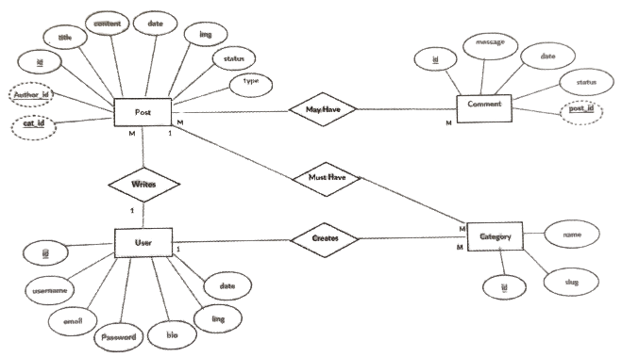

**URL Diagrams**

1. **Use Case Diagram:**

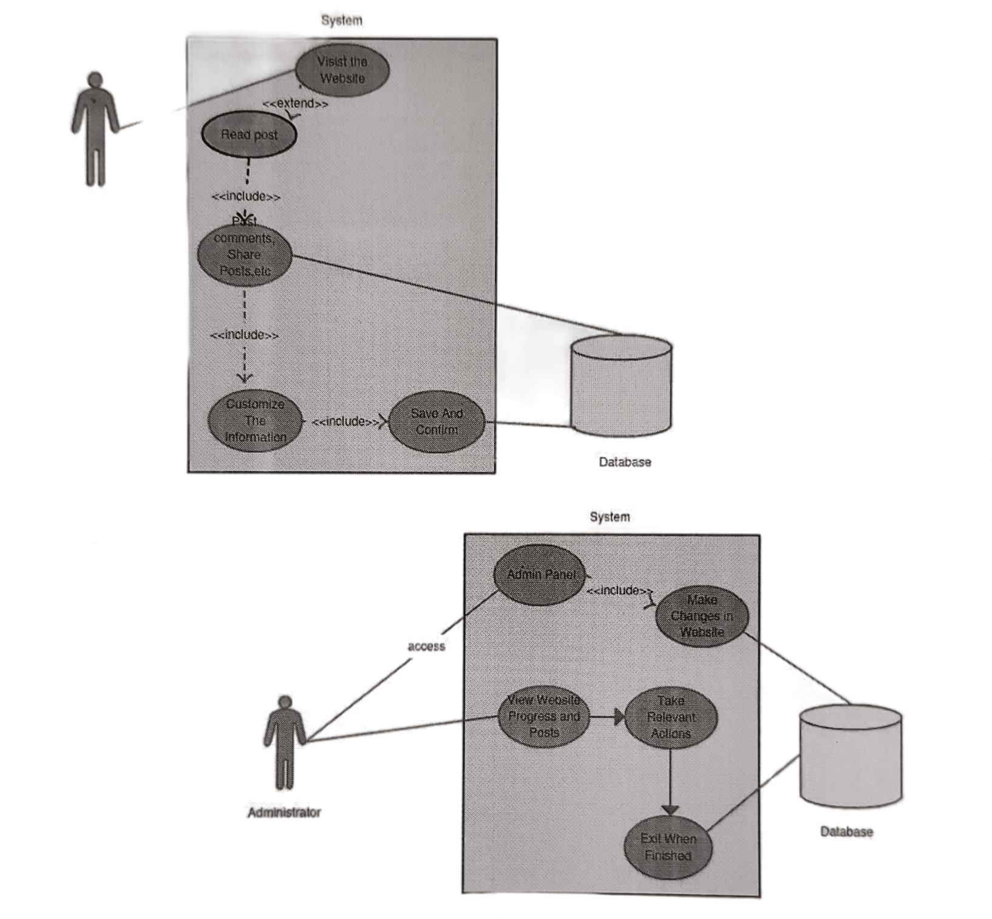

1. **Class Diagram:**

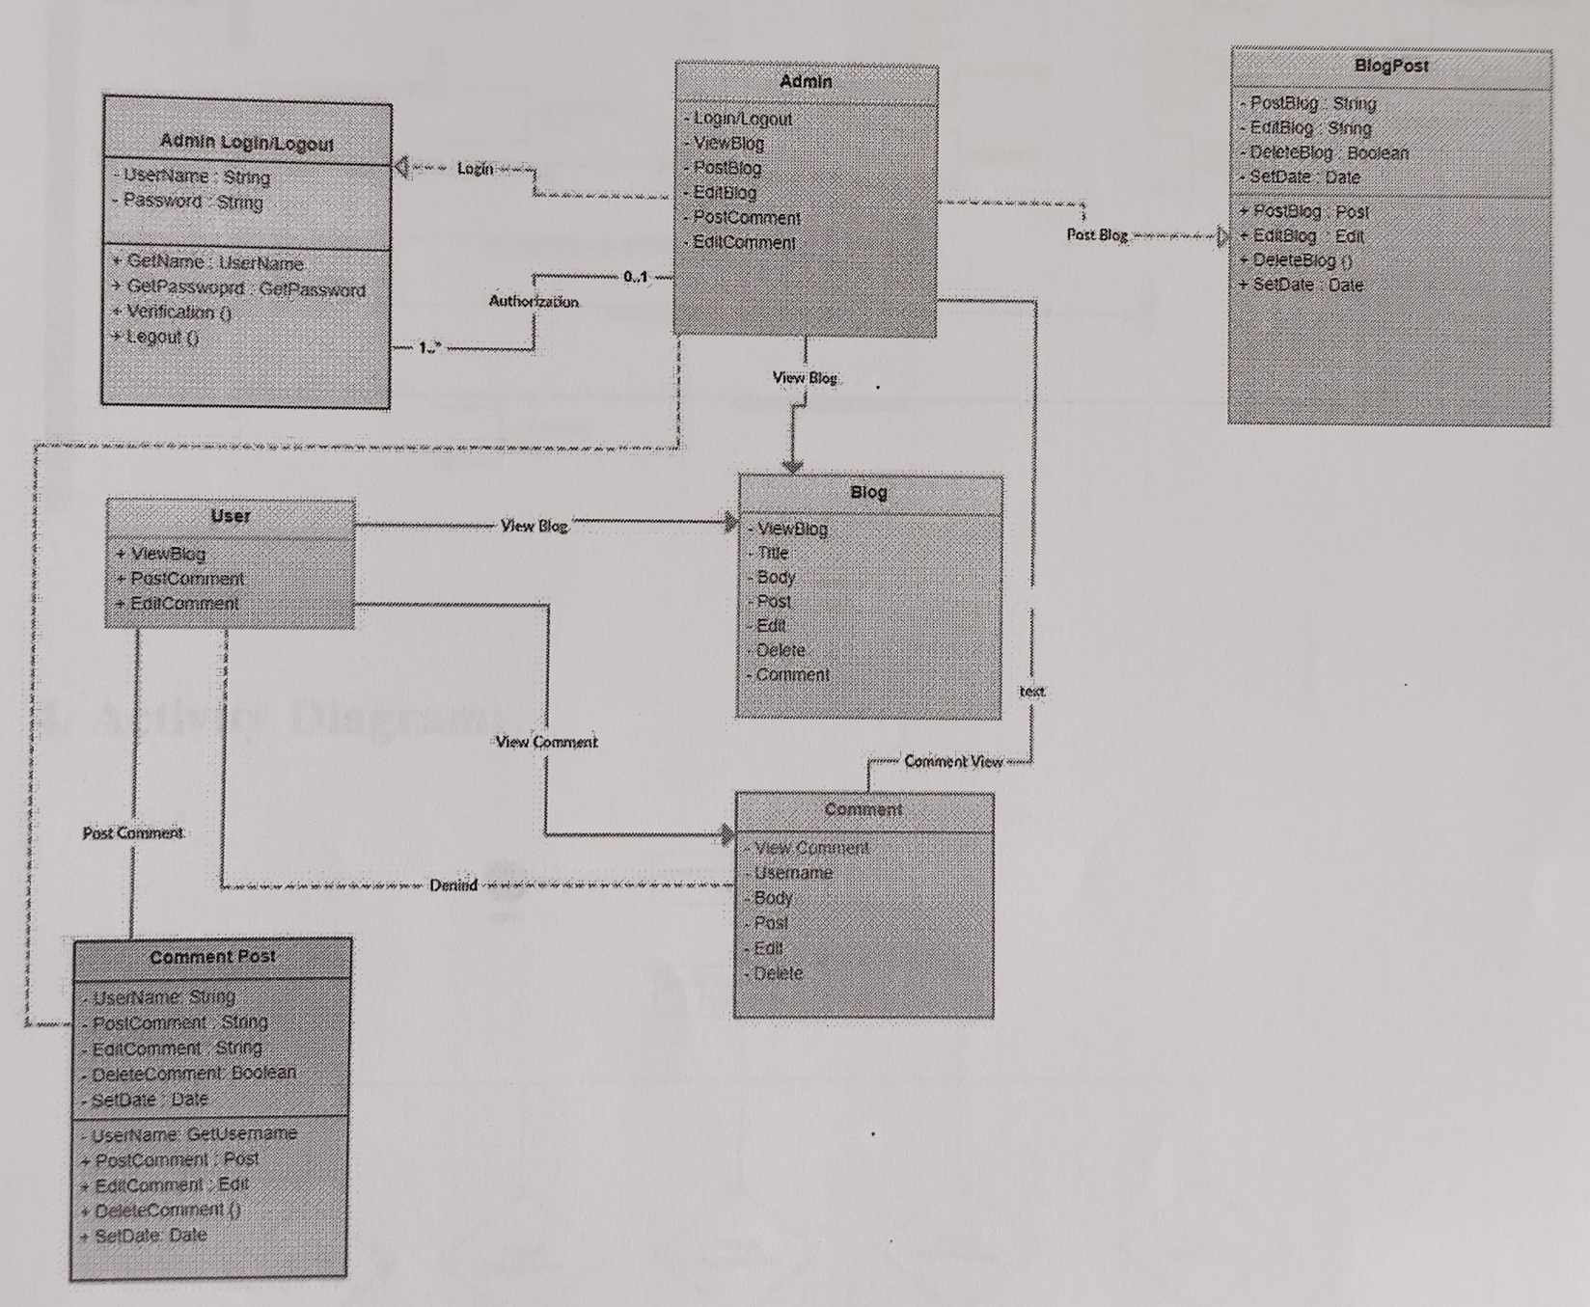

**3.Sequence Diagram:**

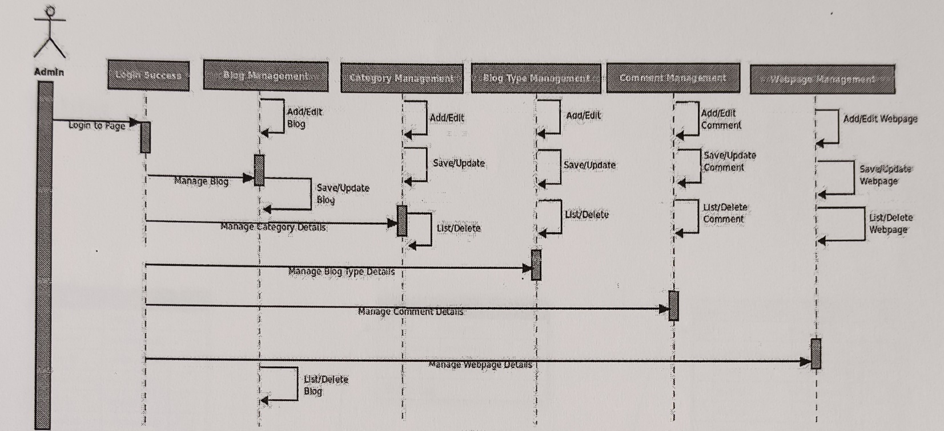

**4.Activity Diagram:**

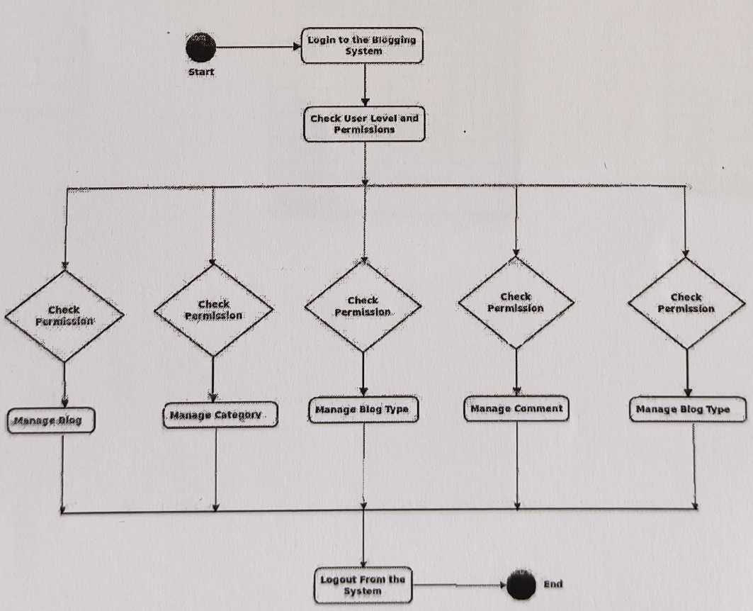

**Data Dictionary**

**Tables:**

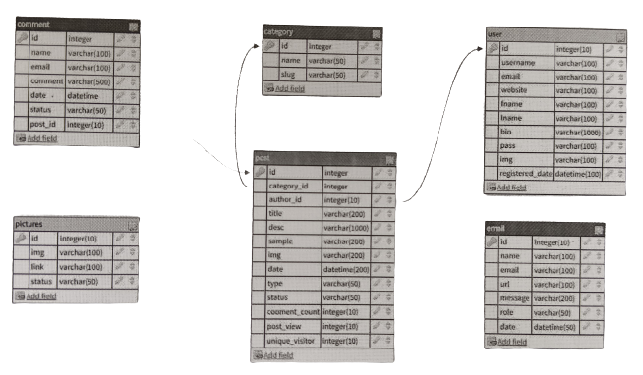

**1.Comment**

|  |  |
| --- | --- |
| **Attribute** | **Data type** |
| id | Int |
| name | Varchar(100) |
| email | Varchar(100) |
| comment | Varchar(500) |
| data | Datetime |
| post | Varchar(50) |
| post_id | Int(10) |

1. **Post**

|  |  |
| --- | --- |
| **Attribute** | **Data type** |
| id | Int |
| Categoty_id | Int |
| Author_id | Int(10) |
| Title | Varchar(200) |
| Desc | Varchar(1000) |
| Sample | Varchar(200) |
| Img | Varchar(200) |
| Date | Varchar(200) |
| Type | Varchar(50) |
| Status | Varchar(50) |
| Comment_count | Int(10) |
| Post_view | Int(10) |
| Unique_visitor | Int(10) |

1. **Category**

|  |  |
| --- | --- |
| **Attribute** | **Data type** |
| Id | Int |
| Name | Varchar(50) |
| Slug | Varchar(50) |

**4.Pictures**

|  |  |
| --- | --- |
| **Attribute** | **Data type** |
| Id | Int |
| Img | Varchar(100) |
| Link | Varchar(100) |
| status | Varchar(50) |

1. **User**

|  |  |
| --- | --- |
| **Attribute** | **Data type** |
| Id | Int() |
| User_name | Varchar(100) |
| Email | Varchar(100) |
| Website | Varchar(100) |
| Fname | Varchar(100) |
| Lname | Varchar(100) |
| Bio | Varchar(100) |
| Pass | Varchar(100) |
| Img | Varchar(100) |
| Registered_date | datetime |

**6.Email**

|  |  |
| --- | --- |
| **Attribute** | **Data type** |
| **Id** | **Int(10)** |
| **Name** | **Varchar(100)** |
| **Email** | **Varchar(100)** |
| **url** | **Varchar(100)** |
| **Message** | **Varchar(200)** |
| **Role** | **Varchar(50)** |
| **Date** | **Datetime** |

**From Design (Input Screen)**

**Blog Home Page**

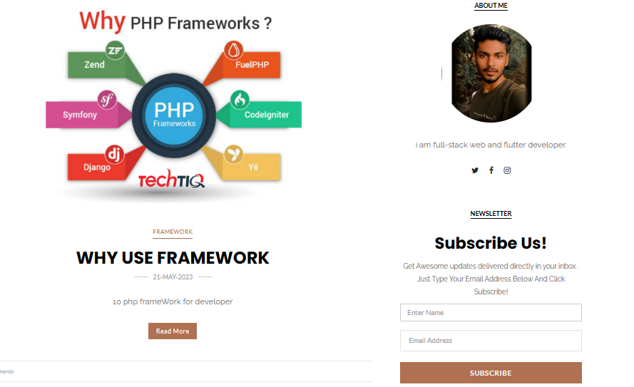

**Searching Post**

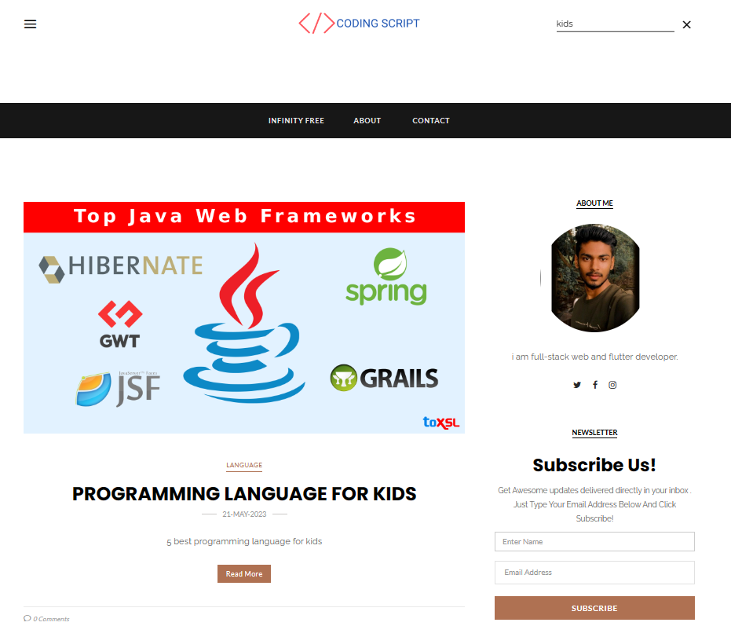

**Single post**

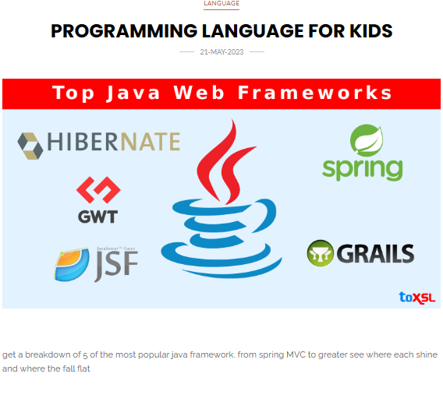

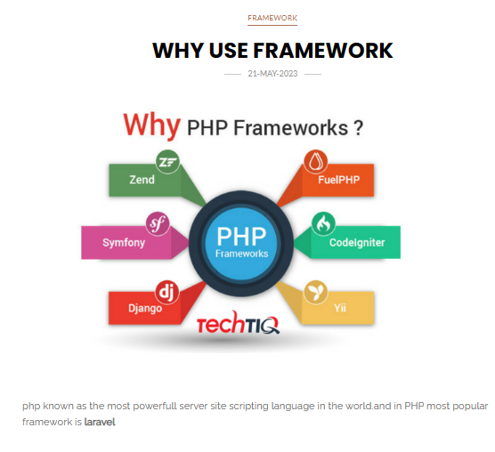

**Category wise post**

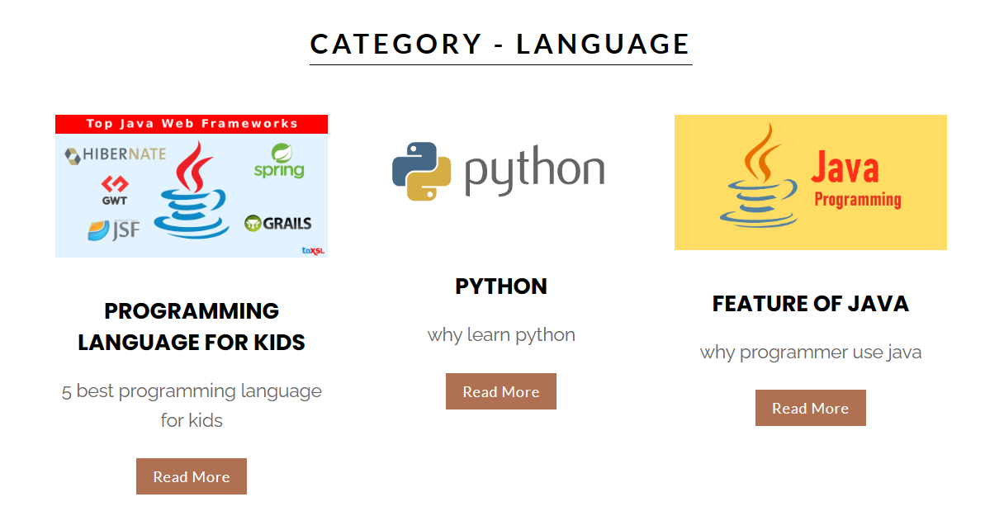

**Sidebar**

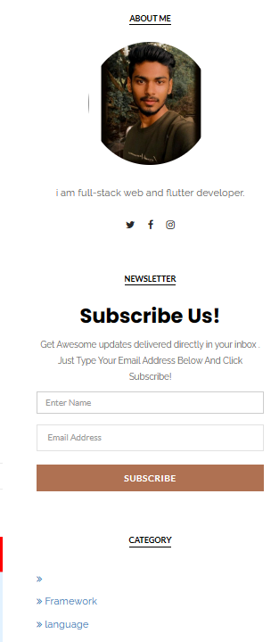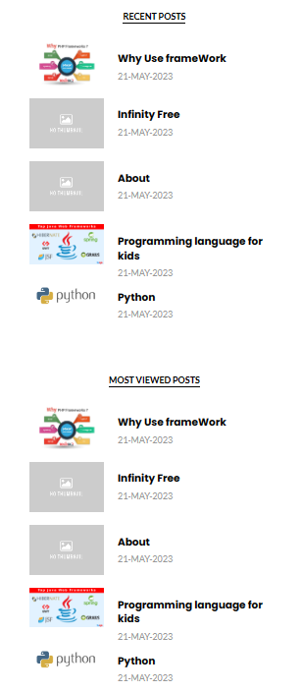

**Contact us:**

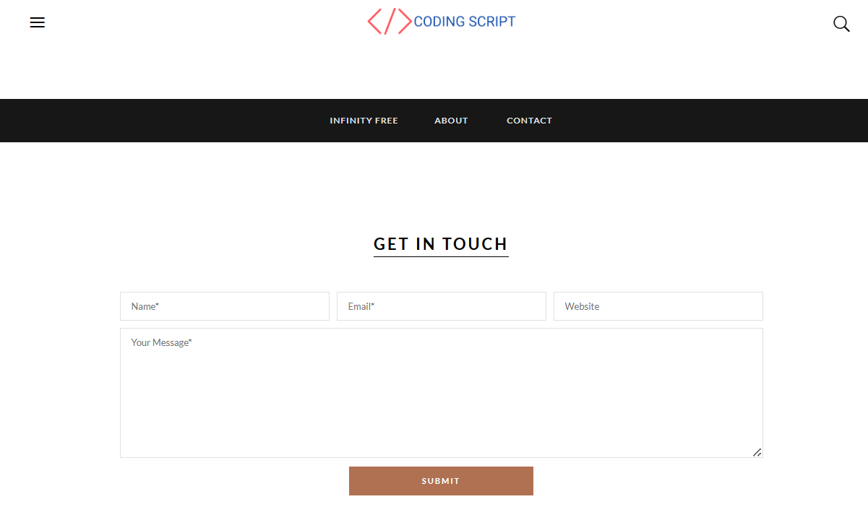

**Admin Register**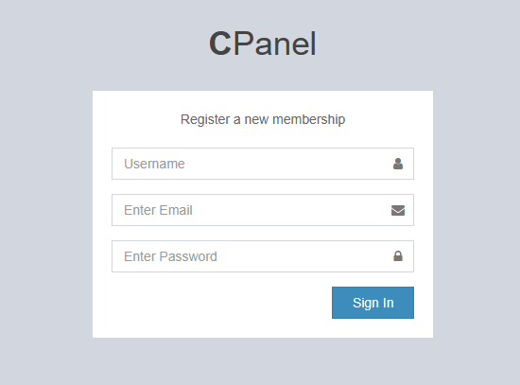

**Admin Login**

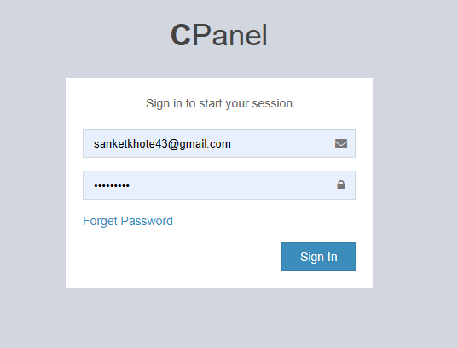

**DashBoard**

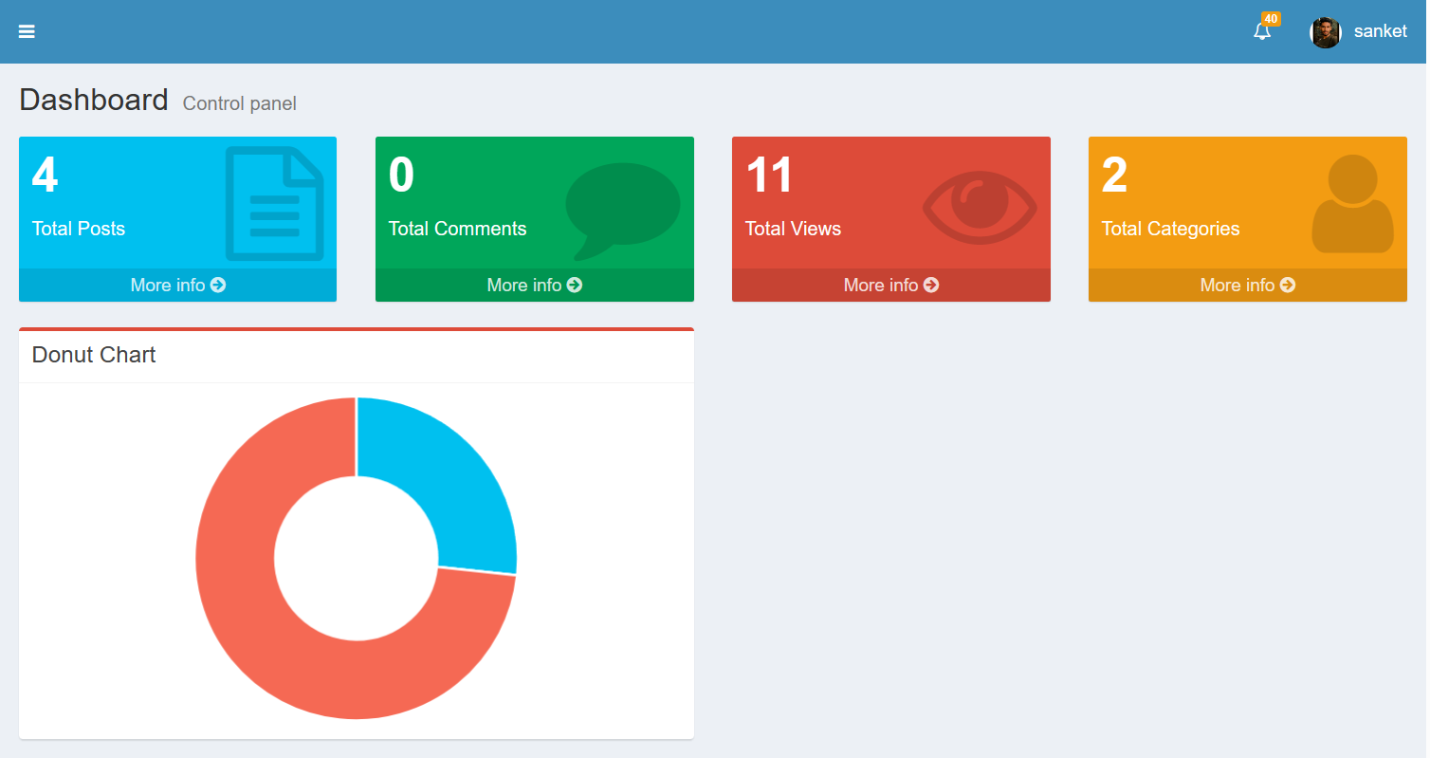

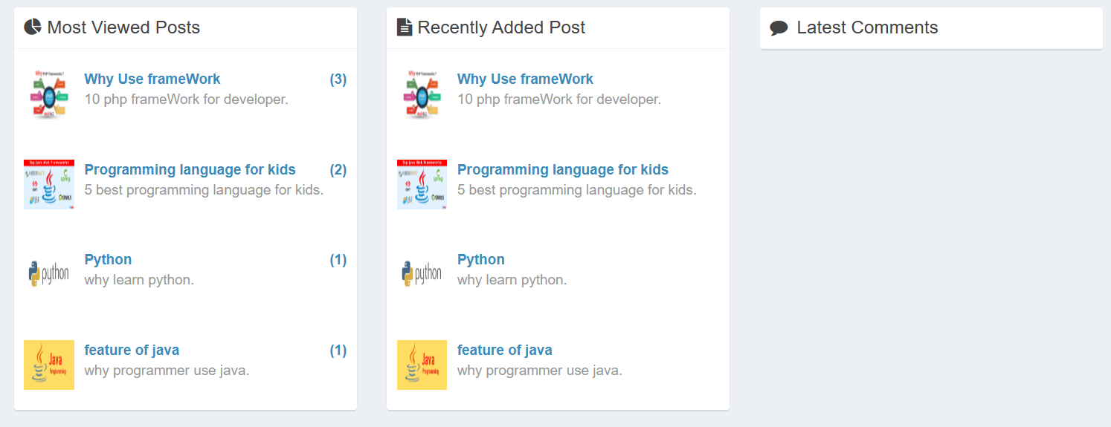

**Notification**

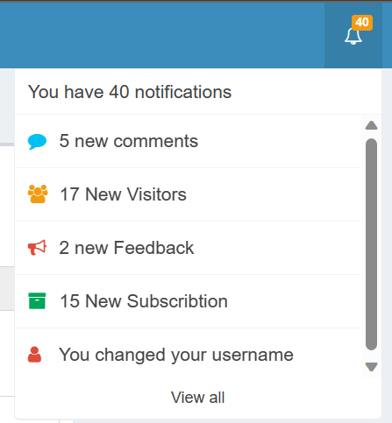

**Profile**

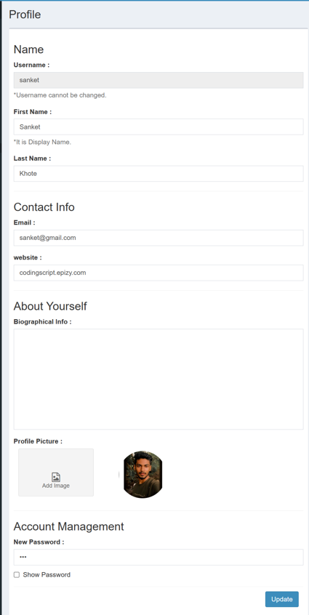

**Category**

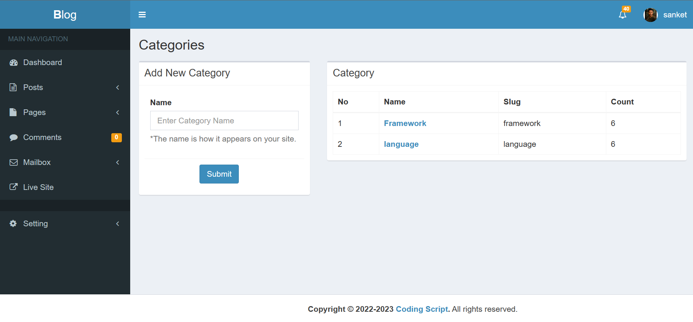

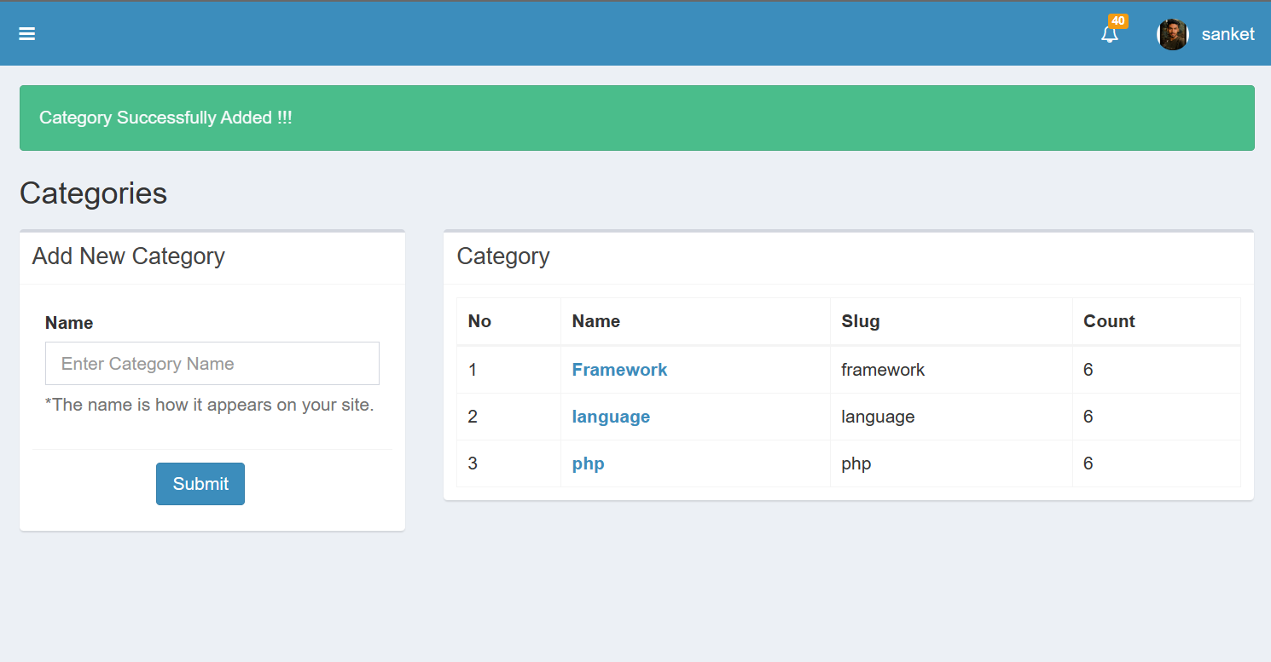

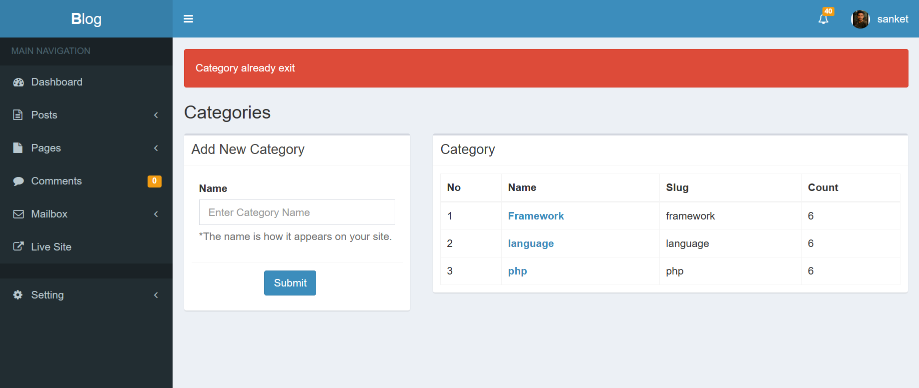

**Add new post**

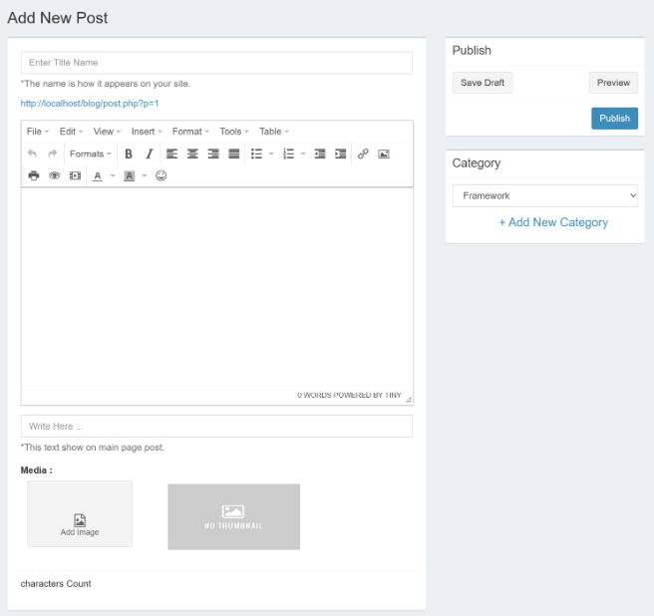

**Edit page/post**

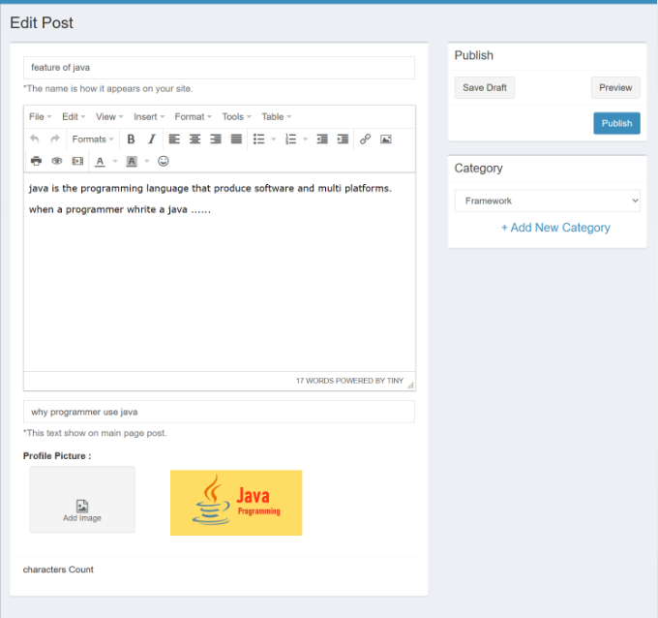

**﻿ Advantages & Limitation**

**Advantages**

* + - Low costs. Due to drastically lower overhead, collecting data does not have to cost you thousands of dollars.
    - Automation and real-time access. Respondents input their own data, and it is automatically stored electronically. Analysis thus becomes easier and can be streamlined, and is available immediately.
    - Less time. Rapid deployment and return times are possible with online surveys that cannot be attained by traditional methods. If you have bad contact information for some respondents, you'll know it almost right after you've sent out your surveys.
    - Convenience for respondents. They can answer questions on their schedule, at their pace, and can even start a survey at one time, stop, and complete it

later.

* + - Design flexibility. Surveys can be programmed even if they are very complex. Intricate skip patterns and logic can be employed seamlessly. You can also require that respondents provide only one response to single-choice questions, which cuts down on error.

**﻿**

**Limitations**

* Limited sampling and respondent availability. Certain populations are less likely to have internet access and to respond to online questionnaires. It is also harder to draw probability samples based on e-mail addresses or website

visitations.

* Possible cooperation problems. Although online surveys in many fields can attain response rates equal to or slightly higher than that of traditional modes, internet users today are constantly bombarded by messages and can easily delete your advances.
* No interviewer. A lack of a trained interviewer to clarify and probe can possibly lead to less reliable data.

**Conclusion**

Overall, I am pleased with the work that I have done on this project. I spent a great deal of time working on the project and while I do not doubt that there are areas that may use some improvement, I feel that my analysis and diagrams represent the best effort I was able to put forth. The process of developing a realistic system reinforced the concepts and diagrams I was learning and enabled me to appreciate their value in the analysis and design process.

One experience during the development of this project particularly stands out for me: Upon writing my detailed use case descriptions, I questioned the validity of the extending use case named "Restart Survey" that I had originally included in the use case diagram. However, I felt I needed more information before I would be comfortable deleting the use case. Upon developing the expanding sequence diagram for use case "Take Survey", I confirmed my belief that the extending use case was unnecessary, as it actually only involved one step which I was easily able to incorporate into the primary use case "Take Survey". This experience, and similar experiences that followed with each new diagram, emphasized the importance of iterative analysis and design work during system development and reinforced how each new diagram enhances and refines the understanding of the overall system.

**Bibliography**

**Reference link:**

https://stackoverflow.com/

https://www.quora.com/

https://www.w3schools.com/php/

https://www.phptpoint.com/php-tutorial/